Contents

Credit Option 2

Sales Page 2

Raw Materials Database 3

Suppliers Database 4

Employee Database 5

Purchases page 6

Employee payroll 10

Database details to be provided 10

a. List of Suppliers 10

b. List of Raw materials used 10

c. List of all Expenses 10

d. Health card details to be listed into the employee database 10

Setting up the application : 11

**Requirements for Second phase of Restaurant Software**

Credit Option**:**

1. The present status of the application is that the sales/billing part is done with the menu list popping up as a pop-up window. The privileges have been taken care of. The login ids of all the different users have been taken into account. The discount part also is working. The welcome screen has been modified as per the theme of the website of the restaurant.

2. The sales type has been default Ala-carte with the table selection enabled for it and disabled for other types. The selection of menu items is done in the pop-up window which has been grouped according to the menu card provided and quantity selection is by both typing the number or by clicking the menu button number of times.

3. The bills can be saved and another bill can be opened but the saved bill will be visible in the current orders and can be opened anytime until it is printed out.

4. The credit option shall be implemented next at the time of printing the bill. The print option shall prompt the user for cash/ credit option (available only for manager/admin privileges only). The cash option shall instantly print the bill with/without discount.

5. The credit option shall prompt the user “New / Existing “ customer. If the customer is new it shall open a pop-up window to enter the customer id, customer name , customer mobile number (optional address). Along with these details the billing date, bill number and billing amount shall be attached to it and saved. The bill is then printed and a copy of it is given to the customer.

6. If the customer is selected as “Existing” then the systems asks for the customer id or mobile number of the customer to track its details.The customer details is opened in the pop-up window with details of the customer id, customer name, mobile number, bill number, bill date and billing amount due. The new details are appended to the existing details with new bill number, new bill date and new billing amount. The new billing amount is calculated and the total amount is printed with all the bill numbers pending, bill amounts pending and total amount due and a copy of it is given to the customer.(Multiple bills for a single customer).

Sales Page **:**

7. The credit reminder should be highlighted at the top of the sales page so that pending dues can be reminded every day until they are followed up and cleared (Only for managers and admin). Clicking on it will give details of customer id, customer name, customer mobile number, bill number, bill date, billing amount due for all the credit customers due.

17. At the bottom corner of the sales page , a bar graph can be added to depict the Total sales per day for the month. If it is starting of the month the start date only will be shown.

Raw Materials Database **:** The details of all the raw materials used. Raw material id, raw material description, unit of measure. 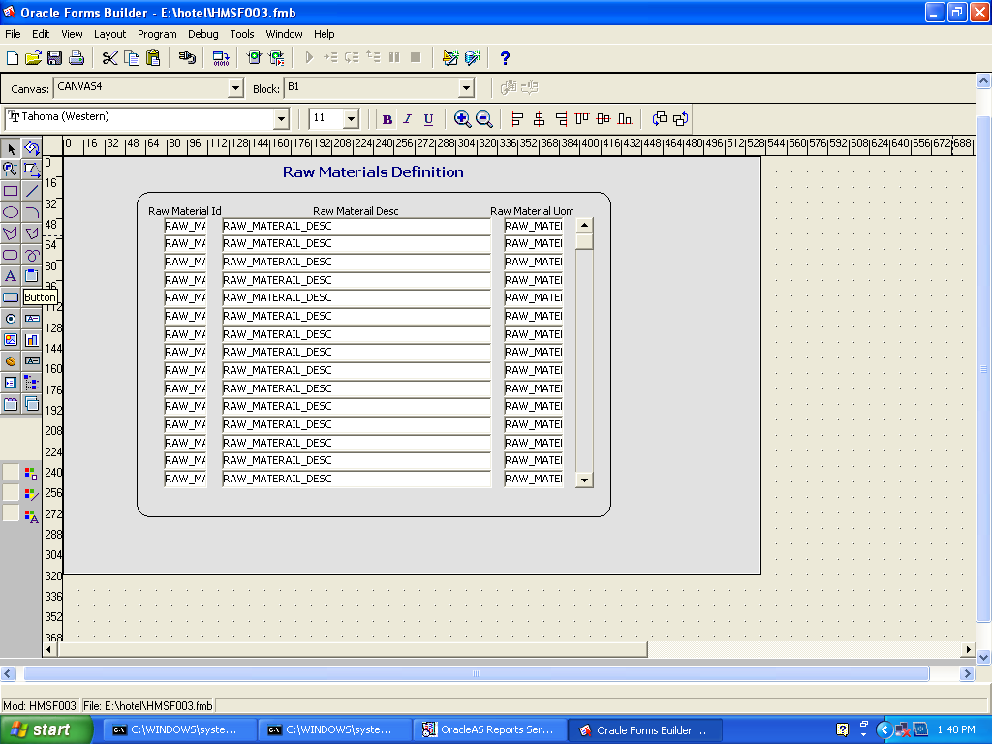

Suppliers Database **:** The details of the suppliers shall be entered here with the supplierid , supplier company name, supplier contact name, supplier contact number.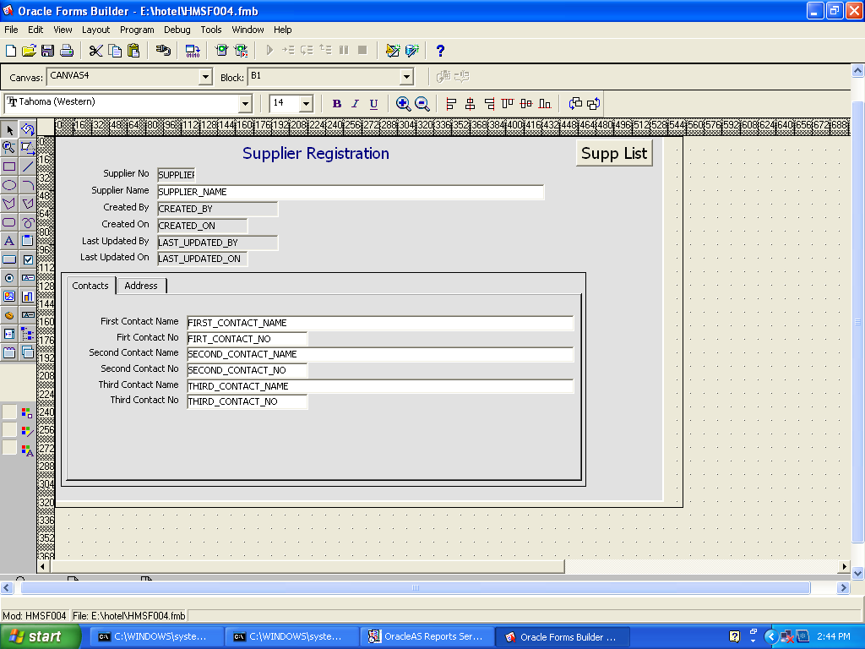

Employee Database **:** The details of the employees with emp_id, emp_name, emp_contacts, passport_no, visa_no, healthcard_1, healthcard_2, etc.

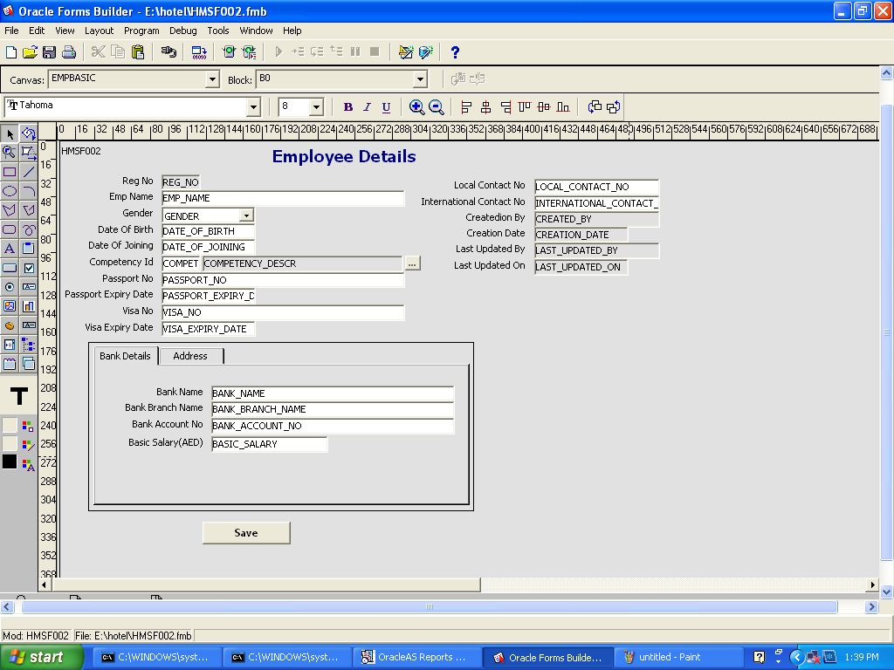

Purchases page **:** The purchases done daily are entered here. The new purchases are entered with details of suppliers , the raw materials purchased, quantity , invoice number, invoice date, invoice total amount. The paid amount is the previous pending bill amount.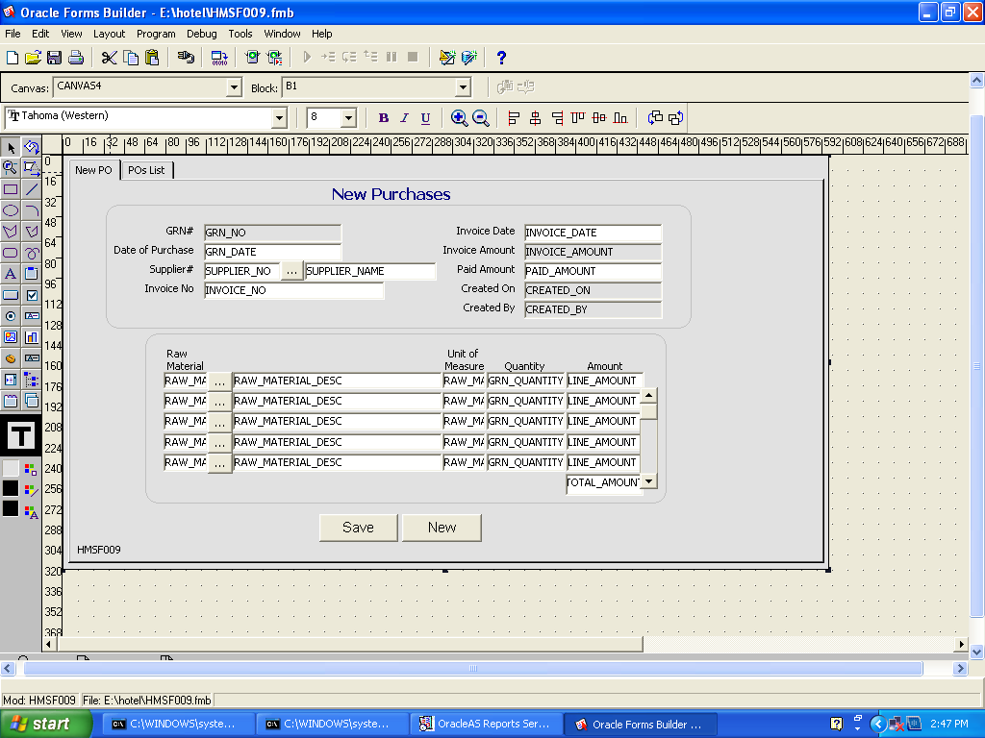

The purchases are done for all the raw materials listed with the ordered quantity, unit price, total amount. The list of all the purchases done are listed out in the purchase order list. The purchases list page shall list out all the purchases made for a particular period with from-date to to-date for a particular supplier or for a particular raw material item as is required .

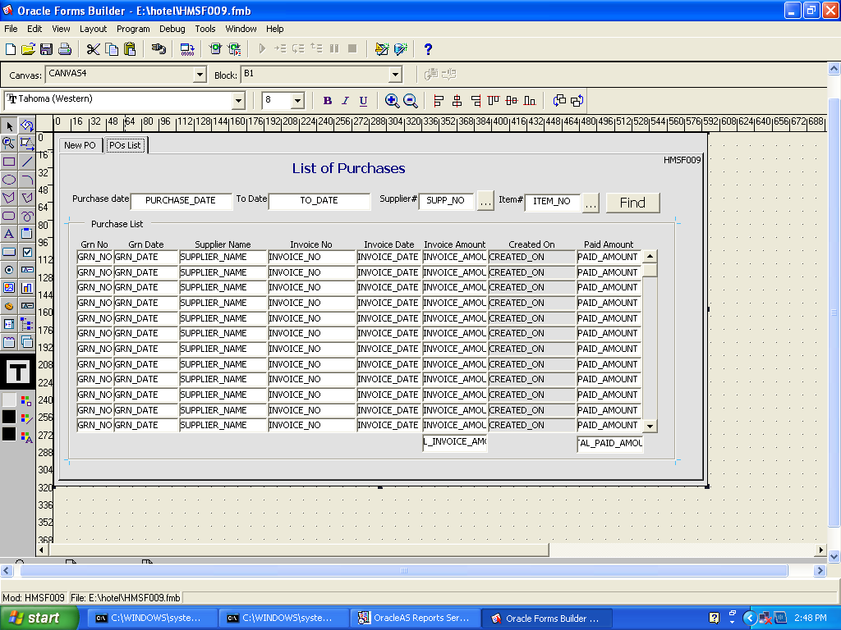

13. The daily payments are the old bill payments done to the supplier.

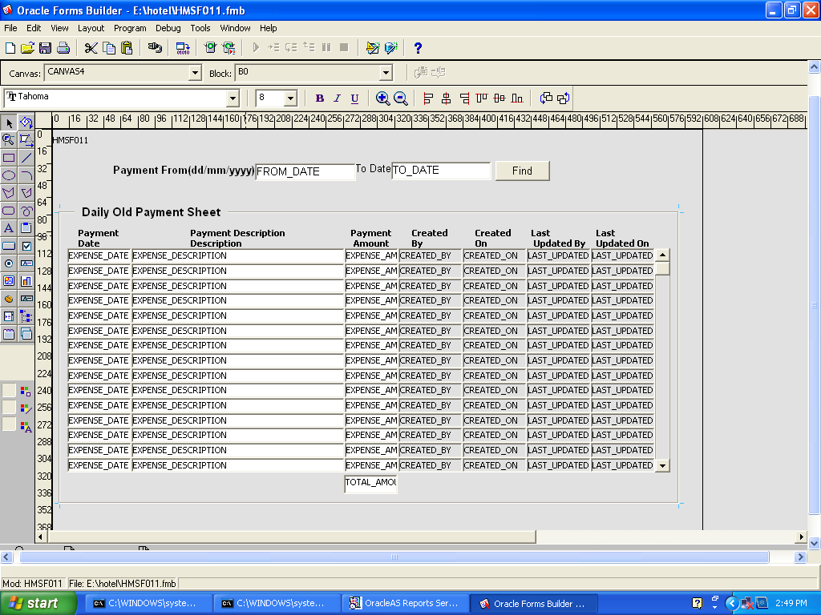

12. The Expenses shall include the other bills like utility bills, rent, electricity bill, visa processing bills etc.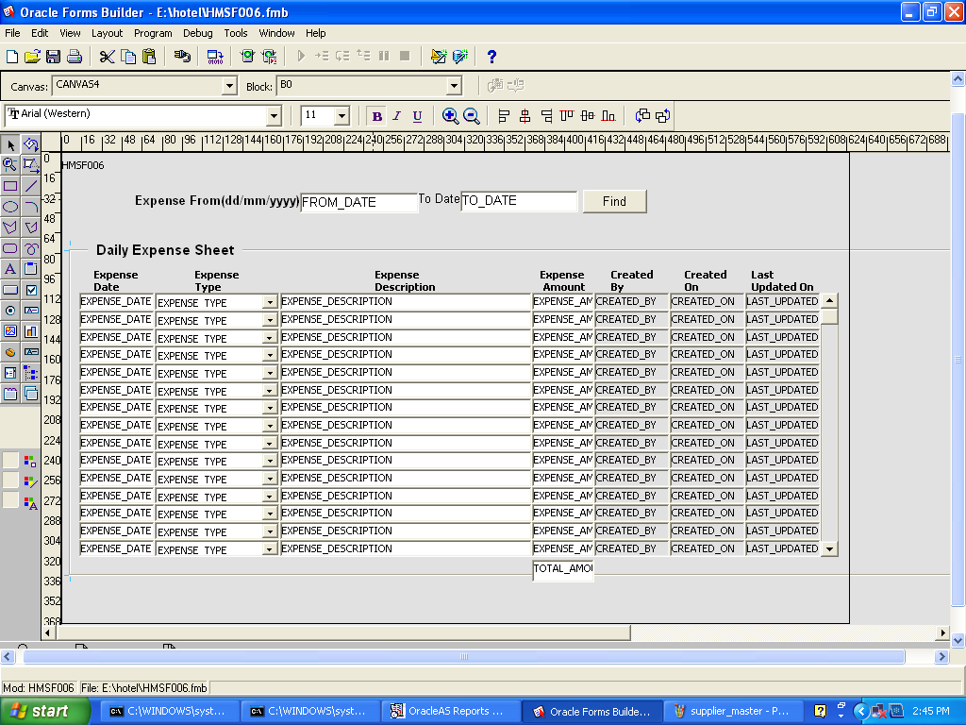

Monthly expenses include employee salary payments and profit sharing by partners & sponsors.

Employee payroll **:** 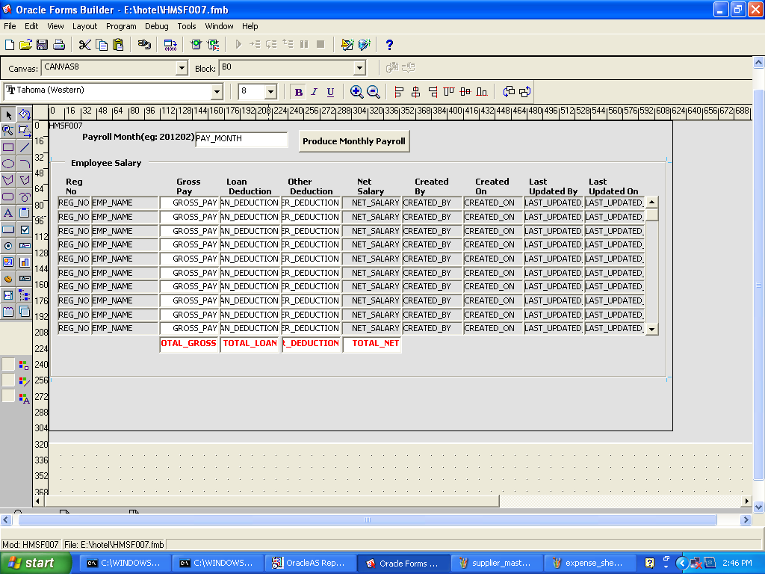

**Reports:**

14. About report generation, the reports shall be monthly (for all days in the month) report for all sales type, Ala-carte, bulk, parcels & credit.

15. Then there should be month-wise reports, ie , for each month of the year, Jan, Feb…….Dec.

16. The reports are again Total sales report, Total expenses report, Total purchases report, Total employee payments(Salaries/payroll) report, partner/ sponsor payment report.

17. Show graphs for all the sales, purchases, expenses and profit.

# Database details to be provided

18. You have to provide details of the following database contents

## a. List of Suppliers

## b. List of Raw materials used

## c. List of all Expenses

## d. Health card details to be listed into the employee database

# Setting up the application :

19. The next is to test the software for an IPOD . Easier to handle as you say.

20. A server can be set up at the restaurant, a laptop with Java and Apache Tomcat installed on it. The WiFi enabled within the restaurant can be used for accessing the IPODs. The application shall be run on the laptop and accessed by all the IPODs though the WiFi connection.

21. Online bookings can be made as a future option.